Day 1 April 23, 2024 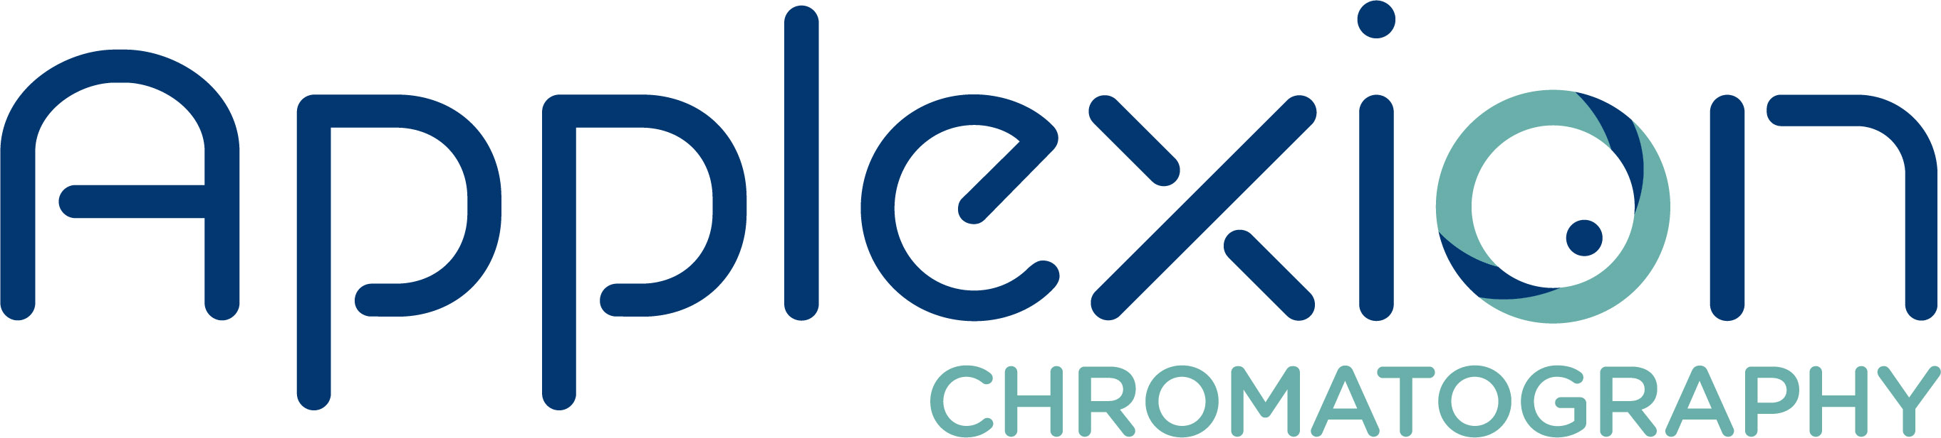 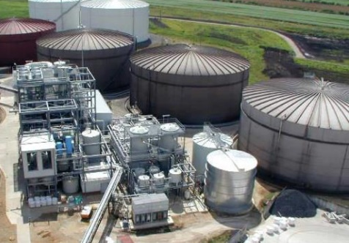 Chromatography Technology & Applications

Time | Topic | Lead
8:15am | Shuttle Pick up at the Holiday Inn
8:20am | Shuttle Pick up at the i-Hotel
8:30 – 9:00am | Breakfast & Registration & Introductions
9:00 – 10:30am | Start of Part 1 of AM Session  - Introduction to Chromatography.  - Deep journey into the theory: chemical & physical interactions, main equations & design implications. | Hector Osuna, R&D Manager
10:30 – 10:45am | Break
10:45 – 12:00pm | Start of Part 2 of AM Session  - Scale-Up: from lab to industrial scale (defining CAPEX and OPEX from trials).  - Batch Chromatography to Continuous Chromatography. | Hector Osuna, R&D Manager
12:00 – 1:00pm | Lunch
1:00 – 3:00pm | Start of Part 1 of PM Session  - Industrial Design: Process design & industrial equipment.  - System Operation: Separation zones, parameters setting, operation sequences, troubleshooting guidelines.  - Case studies: Sugars & Sweeteners, Organic Acids. | Hector Osuna, R&D Manager  Antoine Charbonneau, Process Manager
3:00 – 3:15pm | Break
3:15 – 4:45pm | Start of Part 2 of PM Session  - Digital Tools: Run4.0 & Perform4.0, Link4.0.  - Run4.0 & Perform4.0 digital platforms Demo. | Hector Osuna, R&D Manager  Antoine Charbonneau, Process Manager
5:00pm | Shuttle from IBRL to Networking Reception at Triptych
5:15 - 7:45pm | Networking Reception at Triptych | Triptych
7:30pm | Shuttle from Triptych Networking Reception to Hotels
7:45pm | Shuttle from Triptych Networking Reception to Hotels

The AM session will focus on the basic theory behind the technology, including common terms and definitions, evolution of industrial chromatography, basic flow process, physico-chemical interactions, how separation occurs, modes of operation, resin selection, and how to size a system.
The PM session will focus on the implementation of this technology in industrial plants, including pilot testing, scaling-up, installation/commissioning/operation of a system, as well as typical maintenance and troubleshooting guidelines. It will also include new digital tools presentation for day-to-day operational optimization and digital platforms demonstration (dashboards, data management, etc.).

Day 2, April 24, 2024 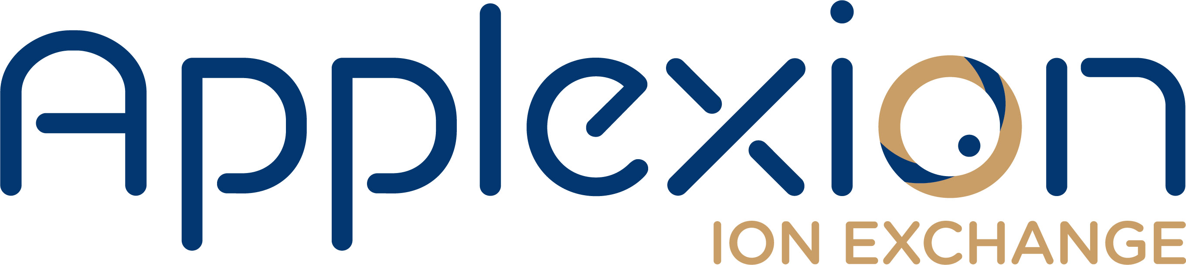 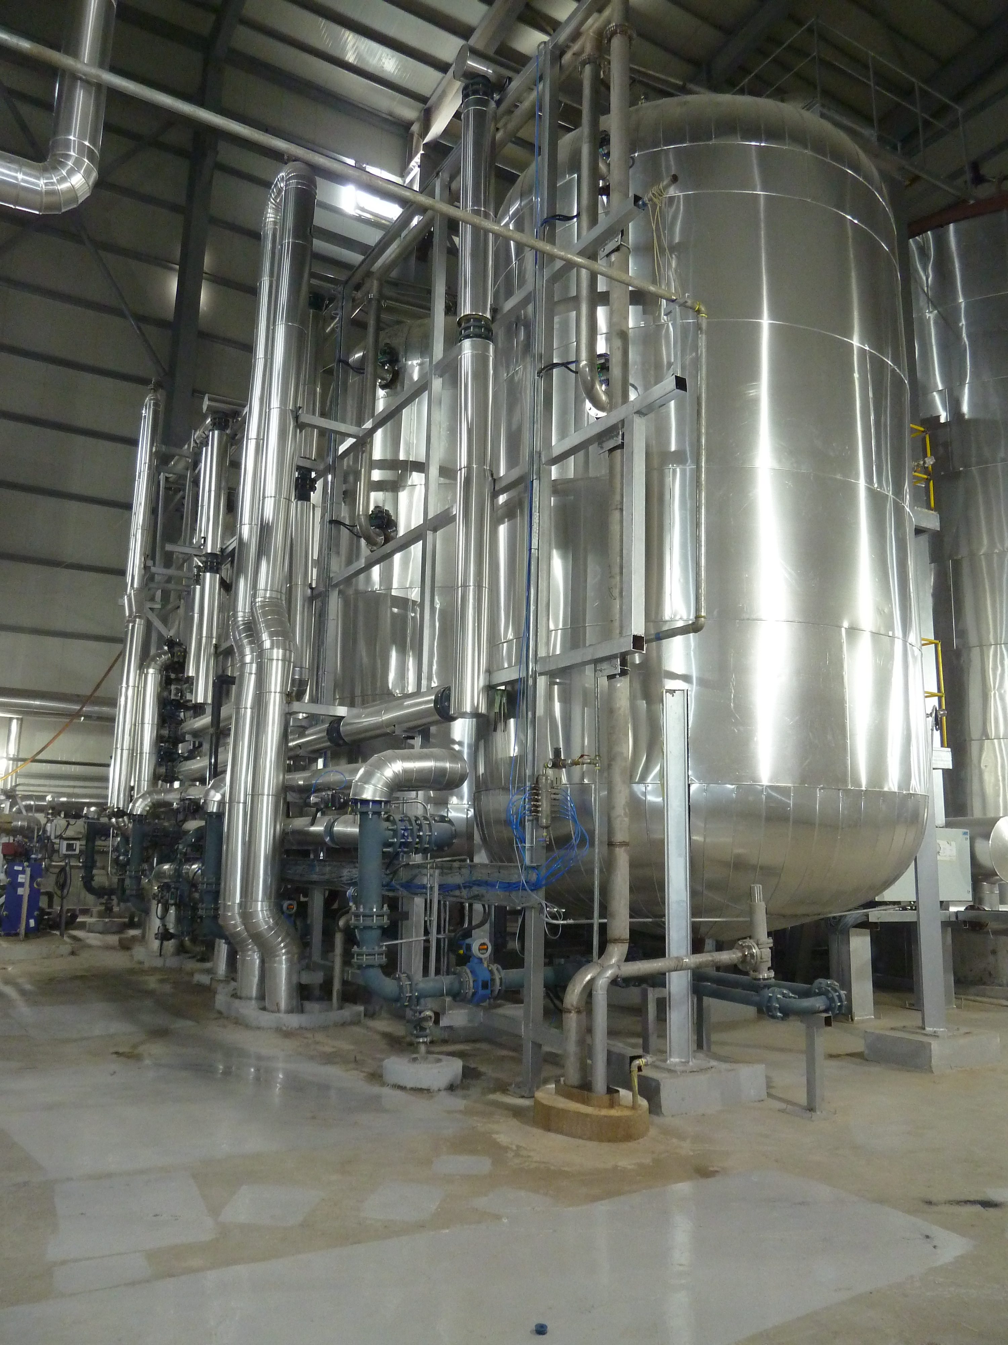
Ion Exchange Technology & Applications

Time | Topic | Lead
8:15am | Shuttle Pick up at Holiday Inn
8:20am | Shuttle Pick up at the i-Hotel
8:30 – 9:00am | Breakfast
9:00 – 10:30am | Start of Part 1 of AM Session  - Introduction to Ion Exchange.  - Deep journey into the theory: chemical & physical interactions, design implications. | Hector Osuna, R&D Manager
10:30 – 10:45am | Break
10:45 – 12:00pm | Start of Part 2 of AM Session  - Scale-Up: from lab to industrial scale (defining CAPEX and OPEX from trials).  - Ion Exchange Resin Types & Applications. | Hector Osuna, R&D Manager
12:00 – 1:00pm | Lunch
1:00 – 2:30pm | Start of Part 1 of PM Session  - Industrial Design: Process design & industrial equipment.  - System Operation: Pressure vessels improvements, recycling, troubleshooting guidelines. | Hector Osuna, R&D Manager  Antoine Charbonneau, Process Manager
2:30 – 2:45pm | Break
2:45 – 3:45pm | Start of Part 2 of PM Session  - Case studies: Sugars & Sweeteners, Amino Acids, Proteins. | Hector Osuna, R&D Manager  Antoine Charbonneau, Process Manager
3:45 – 4:45pm | Tour of IBRL | IBRL Staff
5:00pm | Shuttle from IBRL to Hotels

The AM session will focus on the basic theory behind the technology, including common terms and definitions, evolution of industrial ion exchange, basic flow process, physico-chemical interactions, how purification occurs, modes of operation, resin selection, and how to size a system.
The PM session will focus on the implementation of this technology in industrial plants, including pilot testing, scaling-up, installation/commissioning/operation of a system, as well as typical maintenance and troubleshooting guidelines. It will also include typical case studies review.

Day 3, April, 25, 2024 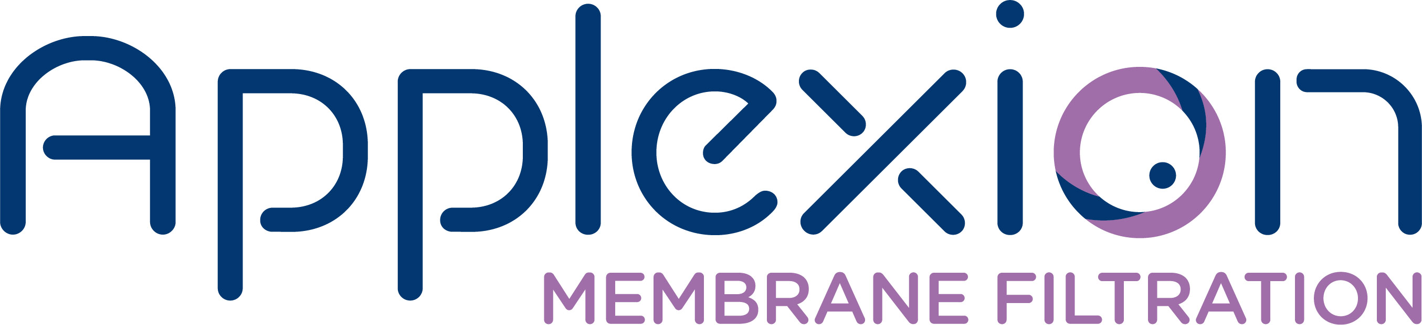 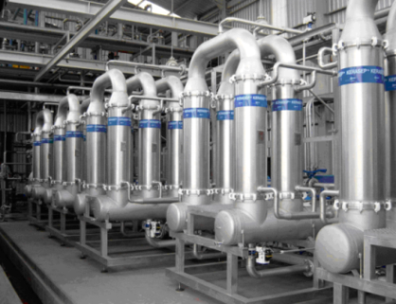
Membrane Filtration Technology & Applications

Time | Topic | Lead
8:15am | Shuttle Pick up at Holiday Inn
8:20am | Shuttle Pick up at I-Hotel
8:30 – 9:00am | Breakfast
9:00 – 10:30am | Start of Part 1 of AM Session  - Membrane Terms and Definitions.  - Ceramic Membranes: Manufacturing, properties, strengths & weaknesses, geometries, pore sizes & configurations.  - Membrane Filtration Process & System: Terms & definitions (Recovery, VCF, diafiltration, etc.), assembly, configurations, batch, fed-batch, etc. | Hafedh Sadani, CPL Manager
10:30 – 10:45am | Break
10:45 – 12:00pm | Start of Part 2 of AM Session  - Ceramic Membrane Selection: Pore size & geometry.  - Case Study: Scaling-Up from pilot testing to the industrial plant. | Hafedh Sadani, CPL Manager
12:00pm – 1:00pm | Lunch
1:00 – 2:15pm | Start of Part 1 of PM Session  - Equipment & Control: Process control, CIP, backpulse, utility recovery, etc.  - Troubleshooting guidelines. | Hafedh Sadani, CPL Manager
2:15 – 2:30pm | Break
2:30 – 4:00pm | Start of Part 2 of PM Session  - Polymeric membrane (UF, NF).  - Case Study: Industrial Membrane system and Complete Process Line. | Hafedh Sadani, CPL Manager
4:00 – 4:45pm | Pilot Plant Demo: Kerasep K01 | Hafedh Sadani, CPL Manager
4:45 – 5:00pm | Certificates & Group Photos | IBRL Staff
5:00pm | Shuttle from IBRL to IHotels

The AM session will focus on the basic theory behind the technology, including common terms and definitions, brief history of ceramic membranes, basic flow process, physico-chemical interactions, how separation occurs, modes of operation, pore size selection, how to size a system, as well as on pilot testing and scaling-up through case study.
The PM session will focus on the implementation of this technology in industrial plants, installation/commissioning/operation of system, equipment and controls, typical maintenance and troubleshooting guidelines, as well as on polymeric membrane and Complete Process Line case study. It will also include a ceramic membrane filtration pilot demonstration.

